English version
Translation of the original Slovak version

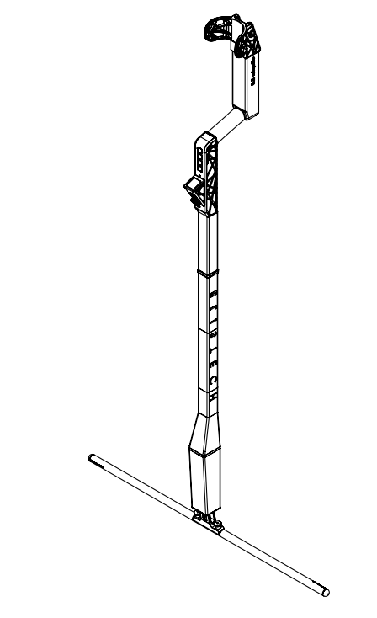

Manual

eRaptor 2.0
High Voltage
Arc
Tester

Elis tech s. r. o.
Živnostenská 2
811 06 Bratislava
Slovak Republic
www.elis.tech
info@elis.tech

Table of Contents
1. Safety instructions 4
1.1 General warnings and safety instructions 4
1.2 Workplace safety 4
1.3 Electric safety 4
1.4 Personal safety 5
1.5 Careful use and handling of electrical equipment 5
1.6 Careful use and handling of battery-operated electrical equipment 5
1.7 Safety instructions for the eRaptor 2.0 electrical device 6
1.8 Use of electrical equipment 8
1.9 Correct and safe position during measurement 9
2. Device description 9
2.1 Components of the eRaptor 2.0 device 9
2.2 Data Specifications 13
3. Control Principles 13
3.1 Keyboard Buttons 13
3.1.1 Esc / Stop button 13
3.1.2 Up / Pause button 13
3.1.3 Down button 13
3.1.4 Power / Enter button 13
3.2 Switching the eRaptor 2.0 on and off 13
3.3 Menu 14
3.3.1 Mesure modes 16
3.3.2 Speaker 16
3.3.3 Bluetooth 16
3.3.4 Settings 17
3.4 System Messages 19
3.4.1 Uncalibrated device 19
3.4.2 SD card missing 20
3.4.3 Overheated equipment 21
3.4.4 Auto power off 22
3.4.5 Charging the eRaptor battery 23
3.4.6 Charging indication and status 24
3.4.7 Battery charge status indication 24
3.4.8 Grounding disconnection 25
3.4.9 Grounding connection 25
3.4.10 Disconnected or damaged equipment 26
4. How to use the device 27
4.1 6. Device assembling 27
4.2 Preparing for integrity testing 28
4.3 Measurement procedure 28
4.4 Switching on the measurement (starting the high-voltage output to the electrodes of the device) 29
4.5 Notification of a leak found 31
4.6 Completion of work with the device 32
4.7 Device maintenance 32
5. Delivery contents 33
5.1 Storage of the device 33
EU Declaration of Conformity 34
Designation: Arc tester 34

Safety instructions

General warnings and safety instructions
Please read these operating instructions carefully before putting the device into operation for the first time, as the procedure in accordance with these instructions is a prerequisite for the correct use of the device. Failure to follow the warnings and instructions below may result in electric shock, fire, serious injury and/or death.
The term “electrical device” or “device” in these notices refers to your battery-powered (battery-powered) eRaptor 2.0 electrical device.
Please keep these warnings and safety instructions carefully for future reference.

Workplace safety
- Always keep the workplace clean and well lit. Clutter and unlit areas of the workplace may result in accidents at work. Keep the handle and gripping surfaces clean, dry and free of oils and grease. Hold the electrical appliance firmly.
- Do not operate this appliance in an explosive area or in an area containing flammable liquids, gases or flammable dust. Electrical equipment creates sparks that could ignite dust or fumes. The electrical equipment must be used exclusively in an open and well-ventilated area.
- Do not allow children and other persons to be in the vicinity of the electrical equipment during use. When distracted by another person, you may lose control of the electrical equipment. Do not let your attention and concentration be distracted by phone calls, etc. When working on scaffolding, ensure that no other person is on the scaffolding. Do not use near another person or animals.
- Do not use the electrical equipment for purposes other than those for which it is intended. Take regular breaks at long intervals (at least every two hours).
- Do not expose the electrical equipment to excessive heat or fire. Exposure to fire or temperature above 50°C may cause an explosion.
- Do not use the electrical equipment in wet environments or environments with possible condensation of moisture. Keep the device, including the electrode, clean. Hold the electrical equipment only by insulated gripping surfaces, otherwise there is a risk of electric shock.

Electric safety
- Avoid physical contact with grounded surfaces such as heating elements, metal pipes, lightning conductors, etc. In case of doubt about the correct grounding of the device, contact the authorized dealer of the device. If the body is grounded, there is an increased risk of electric shock.
- Protect the electrical equipment from the effects of rain and moisture. The ingress of water into the electrical equipment increases the risk of electric shock.
- Do not use the grounding cable for purposes other than those for which it is intended. Never use the grounding cable to pull, carry or lift electrical equipment. Keep the grounding cable away from heat, oil, sharp edges or moving parts.
A damaged or tangled grounding cable increases the risk of electric shock. Never use a damaged or tangled grounding cable.
All electrical equipment must be kept clean and dry , including the electrodes. Moisture, dust or grease on the device may act as a conductor of electric current. There is a risk of electric shock when using contaminated equipment.

Personal safety
- Never operate electrical equipment if your ability to work safely(e.g. with drugs, alcohol, narcotics, etc.) is restricted. A small moment of inattention may result in serious injury or death when using electrical equipment.
- Wear personal protective equipment such as insulating gloves within the meaning of point 1.7, helmet, insulating footwear and long overalls.
- Prevent unintentional starting of the electrical equipment. Before lifting, carrying, storing electrical equipment or changing accessories, check that the grounding cable is pulled out and allow the equipment time of 10 seconds to lose the electrical charge.
- Avoid abnormal body positions. Ensure a firm stance, and keep your balance at all times. This way you will be able to control the power tool better in unexpected situations.
- Notify your surroundings that you are working with a high-voltage device.

Careful use and handling of electrical equipment
- Do not use damaged electrical equipment! Have the device repaired only by a qualified service technician who uses only original identical parts and procedures specified by the manufacturer.
- Do not overload the electrical equipment. Use suitable power tools for your needs. A properly selected tool will do the job better, safer and at the pace for which it was designed.
- Apply pressure to the device only in a straight line with the electrode and do not apply excessive pressure. The electrode may bend, break or cause loss of control.

Careful use and handling of battery-operated electrical equipment
- Never service damaged batteries! Do not open the battery! The battery can be damaged by objects such as nails, screwdrivers or excessive pressure from the outside. The battery should be serviced only by the manufacturer or an authorized service, otherwise there is a risk of fire, serious injury or death.
- In case of damage and improper use of the battery, fumes or liquids may be released. Avoid inhaling these vapors and contact with liquid. After accidental contact, rinse the area with water. If the liquid from the battery comes into contact with the eyes, consult a doctor after eye rinsing. If you inhale fumes, contact a doctor immediately. Leaking liquid and/or vapors from the battery may result in skin irritation, burns, or respiratory irritation.
- Use only the original charging adapter to charge the electrical equipment. Protect the electrical equipment during charging from external influences such as rain, snow, moisture and direct sunlight.

Safety instructions for the eRaptor 2.0 electrical device
- Use the electrical equipment only to detect the integrity of the waterproofing layers in a dry and non-condensing environment. Ingress of water into the device may result in electric shock or death.
- Wear class 4 to 36kV dielectric gloves when using the device and changing work tools. Otherwise, there is a risk of electric shock.
- In the event of a failure of the electrical equipment, it is forbidden to disassemble the device, it is necessary to seek a specialized service or contact the manufacturer. Otherwise, there is a risk of electric shock or fire, burns and/or serious injury.
- Do not attach non-original parts to the device, otherwise there is a risk of burns, electric shock or destruction of the device.
- Do not use the device if you suffer from heart disease or are close to people with a pacemaker or heart disease. Otherwise, there is a risk of death.
- Do not use the electrical appliance unless you have read the instructions for use of the appliance.
- Store the electrical equipment out of the reach of children.
- Keep both hands at a sufficient distance from the area to be measured and the electrode. Do not touch the measuring electrode during measurement or its immediate vicinity. Otherwise, there is a risk of electric shock.


Read all warnings and safety instructions. Failure to follow the warnings and instructions below may result in electric shock, fire, serious injury and/or death.

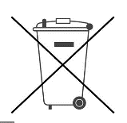
This product is intended to be disposed of at the appropriate recycling center. Do not dispose of this product with household waste. For more information, contact your dealer or local waste collection organization. We support recycling.

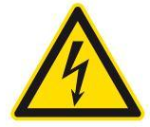
High voltage, do not touch or approach the parts of the device marked with this mark.


It is forbidden to use the device in case of any malfunction. In the event of a malfunction, please contact the manufacturer's technical support.

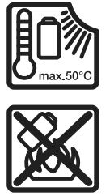
Power tools, rechargeable batteries, accessories and packaging should be sorted with respect to the environment. Do not throw the device into a fire and do not expose it to a temperature higher than 50°C.


Grounding – Grounding wire connection terminal.

Use of electrical equipment
This electrical equipment is designed to check the integrity of non-conductive waterproofing layers. For example, for measuring the tightness of duct and extruded welds, the tightness of attics, skylights, swimming pools, measurements on flat roofs and large open areas. Checking the integrity of various types of non-conductive foil with a thickness from 0.25 mm to 17 mm. The maximum width of the dry weld is 20mm. Suitable types of materials are HDPE, PP, LDPE, TPO, FPO, CSSPE, PVC. The electrical device eRaptor 2.0 can also be used to control double lining systems, however, under the first waterproofing, a control conductive film or other electrically conductive layer must be used.
Non-conductive foil:
- The maximum thickness of the inspected film is 17mm
- The maximum width of the dry weld is 20mm
The principle of operation of the device is shown in the figure.
A Grounded contact of electrical equipment
B Electrical equipment
C Non-conductive waterproofing layer failure site
D Earth grounding
E Electrically non-conductive waterproofing layer

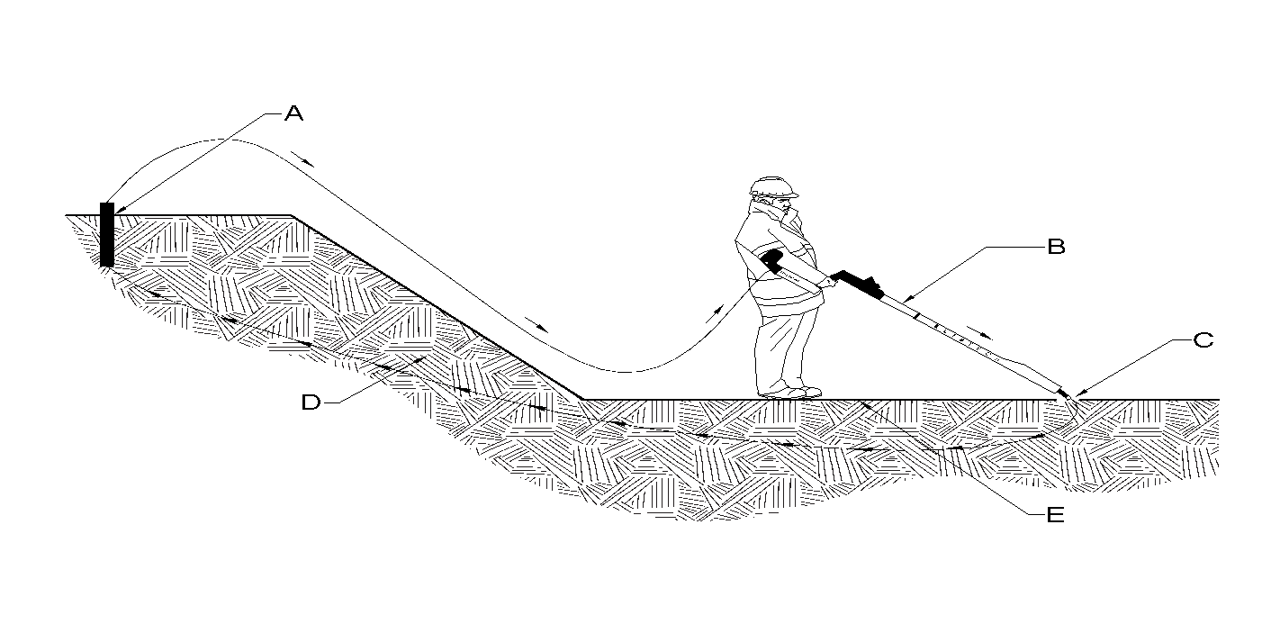

Correct and safe position during measurement
Hold the device by the gripping surface before use. The handle should be held in the hand with the fingers in front. Extend your hand with the device in front of you, press the Power button (see below) to turn on the device.
Before starting the measurement, take the correct position and do not change the position while using the device.
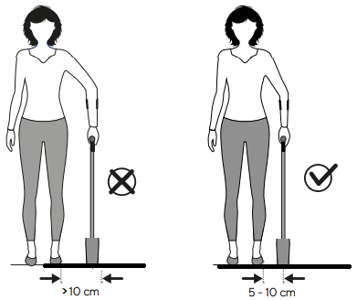

Device description

2.1 Components of the eRaptor 2.0 device
The numbering of the individual components refers to the illustration of the electrical equipment below.
- Device control arm
  - Clamp for attaching the grounding cable
  - Power / Enter button
  - Down button
  - Up / Pause button
  - Esc / Stop button
  - LED indicator of device activation
  - Device display
  - Device loudspeaker
  - USB-C charging slot
  - Device control arm connection connector
  - Ground terminal
  - Mounting points for attaching a mobile phone
- Device detection arm
  - Device detection arm connection connector
  - Device detection arm
  - Spring locking pins
  - Slot for inserting measuring electrodes
- Device electrodes
  - Device electrode guide part
  - Locking part of the electrode
  - Electrode positional hole
  - Electrode measurement area

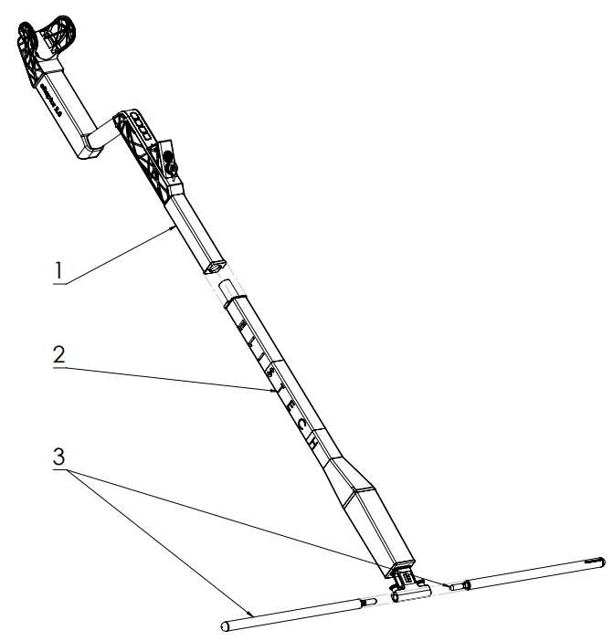
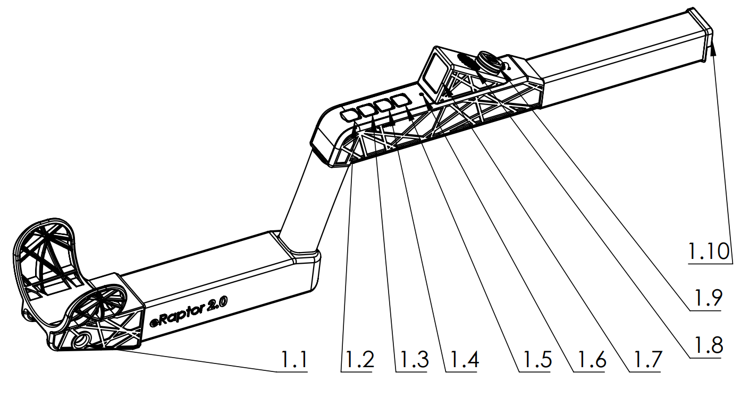
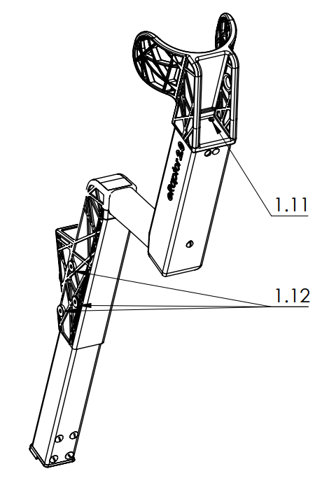

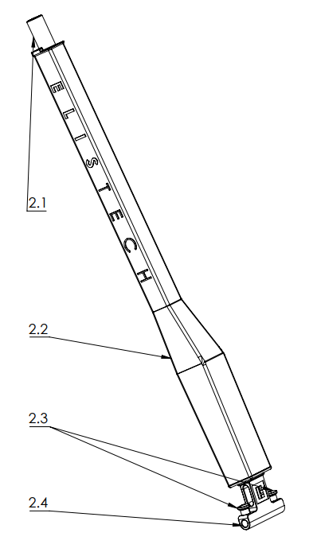
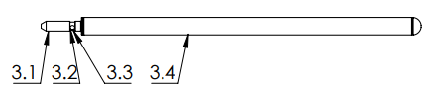

2.2 Data Specifications

Power tools |  |  | eRaptor 2.0
Nominal voltage | V | 14.4V
Output voltage | V | 500-20,000 ± 5%
Battery capacity | mAh | 6450
Weight | Kg | 3.4
Permitted ambient temperature
-when charging | °C | 0...+50°C
-for operation and storage | °C | 5...+50°C
Charging adapter |  | USB – Power Delivery

Control Principles

Keyboard Buttons

Esc / Stop button


Up / Pause button


Down button


Power / Enter button


Switching the eRaptor 2.0 on and off

The eRaptor 2.0 is switched on by holding down the Enter power button for a long time. The device indicates that it is switched on by illuminating the led located between the keyboard and the display.
Switching off the device
- To turn off through the menu:
  - To turn off the device, select the Turn off function in the device start menu
- Emergency stop:
  - If you can't turn the device off or you can't select Turn off, the device can be turned off by holding down the Enter power button for at least 4 seconds.
  - We do not recommend using this shutdown method regularly as it may lead to incorrect shutdown and loss of data on the device.
Notes:
- Regular shutdown via the menu ensures correct storage of settings and data.
- Only use the emergency shutdown if other shutdown methods are not available.

Menu

Navigation menu
After turning on the eRaptor 2.0, the start screen is displayed, which can be accessed with the Up / Down buttons to the MENU item and confirmed with the Enter button.
To navigate the menu, use the Up / Down buttons on the device's keyboard. To enter the individual sections, press Enter. Use the ESC button to return.
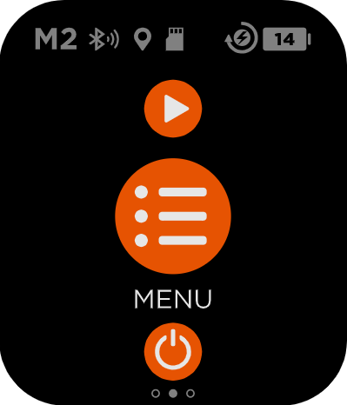

The line marked in solid orange on MODE 3: M3 is the control cursor, the currently selected value is marked by the orange frame MODE 2: M2, see the figure below.
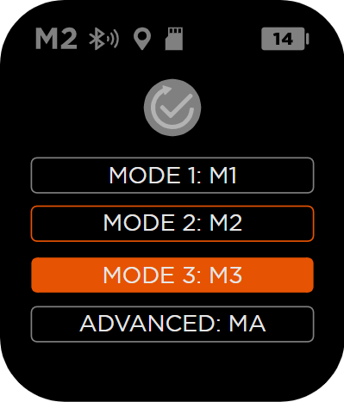

Value setting screen: The figure shows the volume setting screen as an example.
- In the middle there is a value of 40 dB around it, there is also a circular indicator that shows the percentage of the setting, it is the currently selected value, and to turn it on, it is necessary to confirm it by pressing the Enter button.
- The dotted circular pointer shows the value (80dB) that was originally set.
- Press the ESC button to get out of the menu.
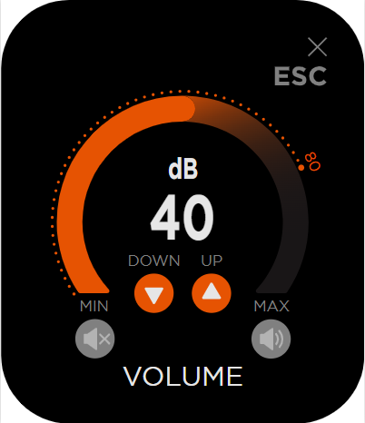
The menu contains categories:
- MEASURE MODE
- SPEAKER
- BLUETOOTH
- SETTINGS
- ACTUAL VALUES
- ABOUT

Mesure modes
In the "Measure modes" menu, users can select from preset measurement modes that are specifically tailored to the device. Each mode is configured with predefined parameters for the sensitivity and output voltage of the device, and is designed to measure different types of non-conductive films. Standard modes High Sensitivity, Medium Sensitivity and Low Sensitivity are designed for standard measurement conditions without a conductive backing. If the composition is with conductive backing, use the ADVANCED mode.
- High Sensitivity HS (1-17 mm): High sensitivity mode
- Medium Sensitivity MS (1-17 mm): Medium sensitive mode
- Low Sensitivity (1-17 mm): Low sensitivity mode
- ADVANCED MA (0.5-17 mm): This setting allows users to customize measurement parameters according to specific needs.
HS, MS and LS are predefined for fast use. However, each measured area has a different composition, so we recommend setting the parameters individually on each roof MA (ADVANCED). The ADVANCED setting procedure is determined as follows: if the thickness of the inspected insulation is below 1 mm, the thickness in mm multiplied by 10 000 is set to adjust the output power. The alarm value should be set to approximately 70% of this value. If the measurement values are stable, the alarm level may increase and thus increase the sensitivity of the device. Conversely, if the values are unstable and fall when moving, the alarm must be lowered below the low unstable values.
The instability of the values may be affected by moisture and dirt below the measured area.

Speaker
In the Speaker menu, you can adjust the volume of the various audible alarms of the device. There are three main types of volume settings that can be customized according to your needs:
- Alarm Volume: This setting determines the volume of the alarm when leaks are detected. The alarm volume can be adjusted from 0% to 100%. A higher volume will ensure that the alarm can be heard well in noisy environments.
- System Volume: This setting controls the volume of system alerts such as low battery, intro sound, device overheating and more. The volume of system alerts can be adjusted from 0% to 100%, allowing the user to customize the audio signals according to the current situation.
- Safety Volume: This setting controls the volume of the audible alert that is activated when the high-voltage output is switched on. For safety reasons, the volume of this alert can only be set between 30% and 100% and cannot be switched off completely. This sound is intended to alert the operator to a potential hazard.
Make sure to adjust the volume to suit your safety needs while ensuring comfort when working with the device.

Bluetooth
The eRaptor 2.0 is equipped with a Bluetooth function that allows wireless connection to mobile devices and other compatible devices. Bluetooth functions are available in the device menu with the following options:
Bluetooth menu options:
Power On/Off:
  - Power On: Activates the Bluetooth function.
  - Power Off: Deactivates the Bluetooth function, saving battery and ensuring that the device is not connected to any Bluetooth devices.
Legacy Mode/BLE 2.0:
  - Legacy: Uses the older version of the ELIS eRaptor mobile application.
  - BLE 2.0: Designed for the eRaptor 2.0 mobile application.
Connection status:
  - Connected: Yes/No
  - Connecting: Indicates that the device is trying to connect to another Bluetooth device.
  - Pairing: Indicates that the device is in the process of pairing with another Bluetooth device.
  - Paired: Indicates that the device has successfully paired with another Bluetooth device.
Bluetooth pairing:
- Device Locator: On your mobile device, locate the available Bluetooth devices and select eRaptor 2.0.
- Start Pairing: After selecting eRaptor 2.0 on the mobile device, the pairing process starts.
- PIN code displaying: The pin code will be displayed on the eRaptor 2.0 display.
- PIN code entering: Enter the displayed pin code on your mobile device and confirm the pairing.
- Device pairing: After successfully entering the pin code, the devices will be paired and ready for use.
Note: Make sure that the Bluetooth function is activated on both devices and that they are placed within range for seamless pairing.

Settings
In the Settings menu, you can customize the various functions of the eRaptor 2.0 to increase the comfort of using it (a detailed description of the individual functions can be found below):

- Reverse Charge: This feature allows the eRaptor 2.0 device to be used as a power source for other devices, such as mobile phones or GPS antennas.
- Flight discharge: When this function is activated, the device will start discharging automatically so that the battery contains the minimum amount of energy required for safe air travel. This minimizes the risk during the flight. This process can take up to 24 hours.
- Display mode: Allows users to change the display mode to light or dark, according to preference.
- Shutdown time: This function allows you to set the automatic shutdown of the device after a certain period of inactivity. The time can be set between 15 and 60 minutes, which helps prevent unnecessary battery discharge.
- Display Brightness: Adjusts the display brightness, with options ranging from 100 to 1000 nits, allowing for optimal readability under various lighting conditions.

Each of these features is designed to improve the user experience and provide greater flexibility and safety when using the eRaptor 2.0.

Flight discharge

Activation and Use of Flight discharge
  - Turn the eRaptor 2.0. on
  - On the main screen go to "Menu" and then select "Settings".
  - In the "Settings" menu, select "Flight Discharge".
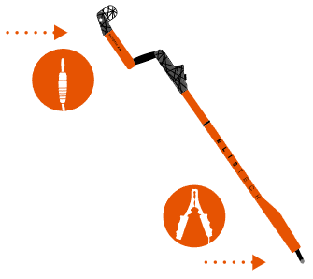
  - After selecting the function, the device may ask to insert the grounding cable and make a short connection. The connection takes place for a short time so that the crocodile clips are attached to the measuring electrode and the banana is then inserted into the grounding terminal. The electrode is not under voltage in this mode.

Discharge process:
  - After activating the function, a screen will appear on the device display showing the current battery status. The device will start discharging automatically. This process can take up to 24 hours.
  - During discharge, it is possible to monitor the battery level on the display, where the percentage state of charge is displayed.
Completion of the process:
  - When the battery reaches the required minimum value of energy required for the flight, the device is automatically switched off.
  - Ensure that the discharge process has been fully completed before handing over the device at the airport inspection.
Important notice:
- Before activating the Flight Discharge function, make sure that you have correctly connected all the necessary components for a safe short-circuit connection. Compliance with these safety steps will ensure that the equipment is properly prepared for safe air travel.

System Messages

System messages:
- Uncalibrated device
- Missing SD card
- Overheated device
- Shutdown
- Charging
- Grounding
- Grounding disconnection
- Grounding connection
- Disconnected or damaged equipment

Uncalibrated device
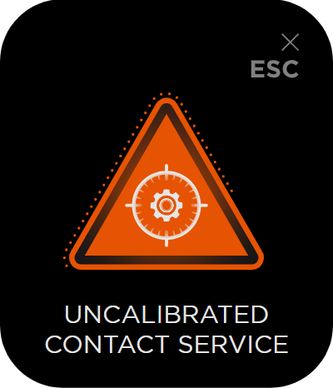
This screen will appear on the display of the eRaptor 2.0 at each boot after a calibration period of 1 year or when prompted by the device. The device signals that recalibration is required to ensure the accuracy and reliability of its measurements and functions.
Procedure for the message "Uncalibrated, contact service":
- Turn the device off: Safely turn the eRaptor 2.0 off
- Contact an authorized service center: To ensure correct calibration and subsequent verification of the correct functioning of the device, contact the authorized service center or the manufacturer's technical support.
- Calibration of the device: The authorized service will perform the necessary calibration tasks, which may include checking and adjusting the internal sensors and components of the device.
- Check after calibration: After calibration, the device is checked and all functions are verified to work properly.
- Recommissioning: After a successful calibration and check, you can safely put the device back into operation.
It is important to perform regular calibration to ensure the high accuracy and reliability of the eRaptor 2.0 and thus the safety and efficiency of its use.
Note: Ignoring this message and continuing to use an uncalibrated device may lead to inaccurate results and potential risks when used.

SD card missing
This screen will appear on the display of the eRaptor 2.0 at each boot unless the device detects an SD card. Although the SD card does not directly affect the basic functioning of the device, it can affect advanced functions and options.
"SD card missing" procedure:
- Restart the device: Alternatively, you can try restarting the device to verify that the message repeats.
- Contact service center: In the event of a missing SD card, we recommend that the customer search for an authorized service center, as the SD card is not easily accessible.
Impacts of missing SD card:
- Data storage: Without an SD card, it will not be possible to store measurement values and other important data in the device memory.
- Graphics displaying : Some graphics and advanced visual features may not be available.
- Audible signals: Audible signals can be simplified, which can affect user comfort and awareness.
It is important to ensure that the SD card is always correctly inserted and functional to ensure the full functionality and reliability of the eRaptor 2.0.
Note: Ignoring this message may lead to limited functionality of the device and loss of the ability to record important data.

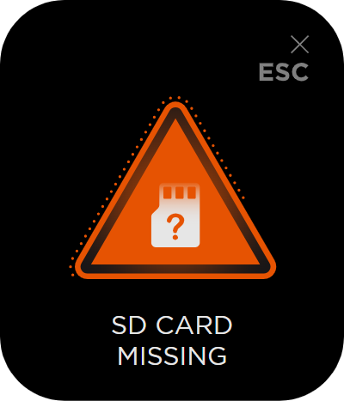

Overheated equipment
This screen will appear on the display of the eRaptor 2.0 when the temperature of the device exceeds the safe operating limit. This condition may indicate a potential overheating that may compromise the proper functioning of the device and its components.
Procedure for "Overtemperature":
- Switch the device off : Safely switch off the eRaptor 2.0 to prevent further overheating.
- Check the location of the device: Make sure that the device is placed in a place with sufficient airflow and is not exposed to direct sunlight or other heat sources.
- Allow the device to cool: Allow the device to cool to room temperature before turning it back on.
- Restart the device: After the device has cooled down, turn it back on and check if the message repeats.
- Contact service center: If the message is repeatedly displayed, it is recommended to contact an authorized service center for further diagnosis and repair.
The effects of overheating:
- Reduced components life: Repeated overheating can shorten the life of internal components of the device.
- Improper operation: Overheating can cause the device to malfunction and affect its reliability and performance.
- Safety hazard: In extreme cases, overheating may pose a safety hazard, including the risk of fire.
It is important to pay attention to this message and take the necessary measures to ensure the safe and reliable operation of the eRaptor 2.0.
Note: Ignoring this message can lead to serious damage to the device and safety hazards.
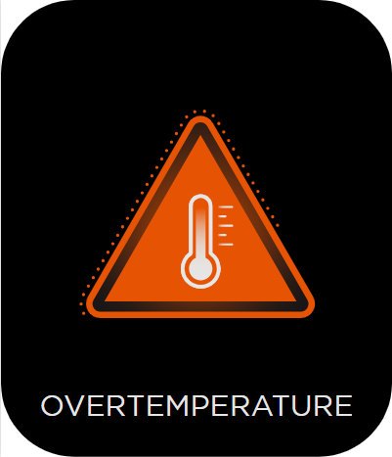

Auto power off
The eRaptor 2.0 has an automatic shutdown function after an adjustable period of inactivity in the range of 15-60 minutes. This feature is designed to save battery and ensure longer device life.
Procedure for "Shutting down" message:
- Automatic shutdown: After the set period of inactivity, the device starts counting down the last minute before shutting down. The display shows a countdown of seconds and the device starts to make a beeping sound.
- Shutdown alert: This beeping sound serves as a reminder that the device will shut down soon. The display will show the countdown of seconds until it is completely turned off.
- Prevent shutdown: To prevent shutdown, press any button on the device during the countdown. This way, the device detects the activity and the automatic shutdown is cancelled.
- Switching off the device: If the user does not respond and does not press any button on the device, the device will automatically switch off after a set period of inactivity.
Benefits of the auto-off feature:
- Battery saving: Automatic shutdown helps to save battery by preventing the device from discharging unnecessarily during idle time.
- Extended service life: Regular shutdown during inactivity contributes to a longer service life of the device.
- Safety: Automatic shutdown can help prevent overheating and other problems associated with long-term unattended operation.
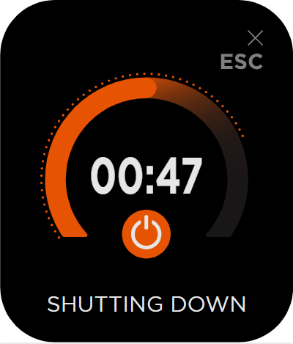

Charging the eRaptor battery

Use only charging adapters with PD protocol 3.0 and higher. If the device is not in use, charge it continuously at least once every 180 days.

Caution: The battery is supplied in a partially charged state. To ensure full performance, fully charge the battery before first use.
If the eRaptor 2.0 is deeply discharged, for example, if the user stores it with less than 10% of the battery and does not use it for a long time, the device cannot be charged with a USB-C charger. In this case, it is necessary to seek an authorized service.
Lithium-ion batteries can be recharged at any time without adversely affecting their service life. Interrupting charging does not damage such a battery.

eRaptor 2.0 is equipped with a USB-C charging connector, which is shown under the cover in section 2.10, connect the USB-C cable to the eRaptor 2.0 port and the other end to the charging adapter. Charging cable with charging adapter included.
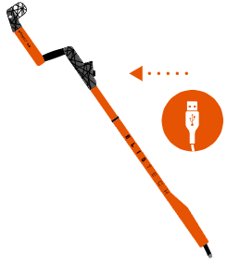

Charging indication and status

The display of the eRaptor 2.0 shows the inscription CHARGING and an animation showing charging, after a while the state of charge of the battery is displayed. The device may heat up in place of the keyboard during charging.
When the "Charging" screen appears on the display of the eRaptor 2.0, it means that the device is connected to a power source and its battery is being charged. Allow the device to charge continuously until fully charged. It is recommended not to disconnect the device while charging unless necessary.

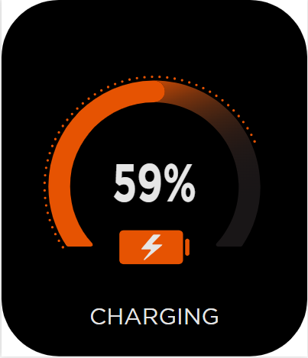
During charging of the electrical device, the functionality of the device is blocked for safety reasons.

Battery charge status indication

On the display of the device, it allows the indication of the state of charge of the battery. To indicate the state of charge of the battery, hold the switch on the device and wait for the initial screen to display the indication of the state of charge of the battery in the upper right corner.

Grounding
When the message "Unplugged" appears on the eRaptor 2.0 device display, it indicates that the grounding cables are not properly connected. For your safety and for the correct operation of the device, it is essential that these cables are properly attached.
Checking the Grounding Cable:
- Verify that the grounding cables are correctly connected to the device and to the grounding terminal.
- Ensure that all connections are secure and free from visible damage.
Connecting the Cable:
- If you find that the cable is not connected, attach it to the proper location as described in the manual.
- Once connected, you may continue using the eRaptor 2.0 device as needed.
- After connecting the grounding cables, the "Unplugged" warning should disappear from the display.
- If the warning persists, recheck the connections and make sure the grounding cable is not damaged.
Safety Warning:
- Do not touch any other metallic parts of the device while connecting or inspecting the cables.
- Always wear protective gloves and follow all safety instructions for handling electrical components.
Proper connection of the grounding cable is critical for the safe and efficient operation of the eRaptor 2.0 device. By following these steps, you ensure that your device operates correctly and safely.

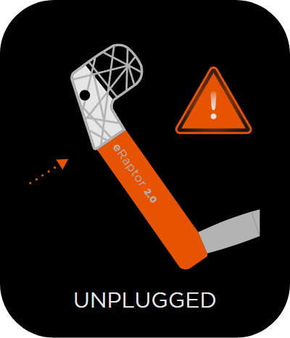

Grounding disconnection
When the “Unplug” screen appears on the device display, the device notifies you that you need to disconnect the grounding cable. Follow the steps below to proceed:
- Gently disconnect the grounding cable from the device. Check that the cable is not damaged or worn. If you find any signs of damage, do not use the cable and replace it.
- Make sure that the connector on the device is also clean and free from damage.
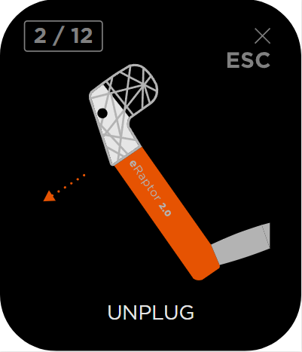

Grounding connection
When the "Plug In" screen appears on the device display, the device prompts you to connect the grounding cable. This warning usually appears before the start of the operation or when it is necessary to ensure the safe operation of the device. Follow the steps below to proceed:
Checking the grounding cable:
  - Check that the grounding cable is in good condition and shows no signs of damage or wear. If the cable is damaged, it must be replaced before using the device.
Connecting the grounding cable:
  - Gently connect the grounding cable to the appropriate connector on the device. Make sure that the connection is firm and secure so that there are no interruptions during the use of the device.

Verify correct connection:
  - After connecting the cable, turn on the device or continue using it as needed. Monitor whether the "Plug In" warning on the display has disappeared to confirm the correct cable connection.
Safety warnings & cuations :
  - When handling the cable, make sure that the device is switched off to avoid possible electric shock.
  - Avoid touching the metal parts of the cable with your hands or other objects to avoid an unwanted short connection.

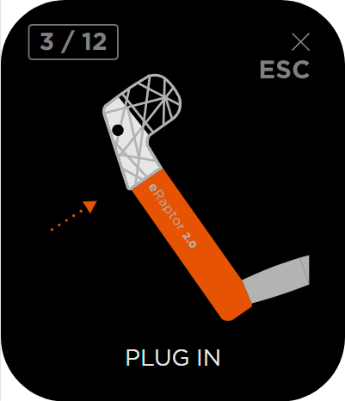

Disconnected or damaged equipment
When "Disconnected or Defective" appears on the display of the eRaptor 2.0, it indicates a possible problem with the connection or functionality of the lower part of the device. This alert requires your attention to ensure proper operation of the device.
- Lower part connection check:
  - Check that the lower part of the device is properly and firmly connected to the main unit.
  - Make sure all connectors are clean and free from damage.
- Reconnecting the lower part:
  - If you find that the connection is loose, disconnect the lower part and re-engage it firmly.
  - Ensure that the connectors are not blocked or contaminated by dust or other debris.
- Functionality testing:
  - After reconnecting the lower part, turn the device on and check whether the warning has disappeared.
  - Try to use the device as usual to verify that the issue has been resolved successfully.
- Defects resolving:
  - If the “Disconnected or Defective” warning persists after reconnection, it is possible that the lower part is damaged.
  - In this case, it is recommended to contact the technical support or service center for diagnosis and possible repair or replacement of the lower part.
- Safety notice:
  - Always observe safety regulations when handling electronic components.
  - Before handling the device, make sure that it is disconnected from the power supply.
By using these steps, you will ensure that your eRaptor 2.0 device will function properly and safely. In case of any doubts or problems, always consult an expert or a service center.
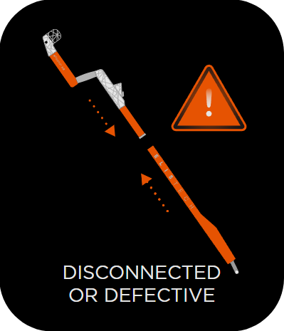

How to use the device

Always follow the instructions and follow the procedure for preparing and completing work with the eRaptor 2.0.

Device assembling
To assemble the device, we need to proceed with the following steps and follow their order.
- Remove the detection arm and insert the electrodes into it.
- Fix the electrodes and check whether they are properly seated.
- Take out the control arm and connect it to the detection arm and make sure they are held firmly enough.

- Follow the prescribed procedure for assembling the ELISTECH eRaptor 2.0 device. Incorrect installation procedure can cause electric shock, in some cases even death.
- Always follow the instructions and follow the procedure for preparing and completing work with the eRaptor 2.0.

Preparing for integrity testing
- Before starting the measurement, check that the electrical equipment is dry, clean, free of grease and does not show signs of mechanical damage.
- Check that your device is charged.
- Assemble the eRaptor 2.0
- Before using the device, it is necessary to find a suitable grounding point on which to attach the grounding cable (not included). In case of doubt about the correct grounding of the device, contact the authorized dealer of the device. To ground the device, use only a grounding cable designed to ground the eRaptor 2.0 device, such as the eCable 6, eCable 30 or eCable 150, which affects the proper functioning of the device and at the same time performs a safety function.
- Wear protective equipment. In particular, class 4 to 36kV dielectric gloves, long overalls, insulating shoes and a helmet.
- Start the measurement with the eRaptor 2.0 device (see Section 2 )

Measurement procedure
The grounding connector must be connected to the grounding terminal (see Section 2) the entire period of checking the integrity of the non-conducting film. Always when interrupting work, pausing the measurement, turn off the high-voltage power supply by pressing the Stop or Pause button on the device keyboard (see Section 3). When replacing the measuring electrode, turn the device off and disconnect the grounding cable from the eRaptor 2.0, then leave the device idle for at least 10 seconds to lose all electrical charge.

Warning: The electrical device eRaptor 2.0 always emits an audible alarm for a short time when the high-voltage output is switched on, which indicates that the high-voltage electrode has been charged with an electric charge.

If the DISCONNECTED OR UNPLUGGED animation appears on the device screen, it means that the device is not ready for measurement because it is either unconnected, poorly connected or the correct grounding cable is not connected.
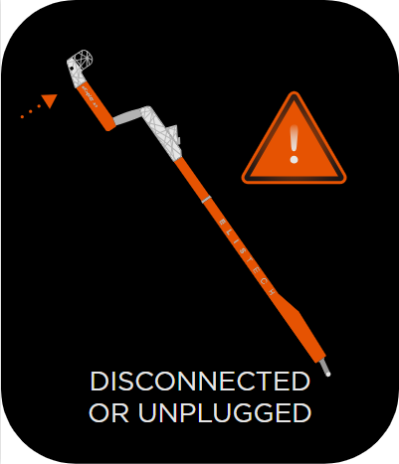

- Assemble the eRaptor 2.0 as instructed in Section 2
- Ground the device using the crocodile clips on our eCable 150 with the right clip, for example on the lightning rod if you are on the roof, or directly with a pin into the ground.
- Insert the grounding connector into the grounding terminal (see Section 2) on the eRaptor 2.0.
- Turn the eRaptor 2.0. on
- Set the desired measuring mode of the device.
- Turn on the high-voltage output, pass the electrode around the place where you grounded yourself. If the display of the electrical device decreases the signal values and the device emits an acoustic signal during the passage of the measuring electrode over this place (for example, the lightning rod on the roof or the ground into which you inserted the pin), you have the device properly grounded, and you can start checking the integrity of the required area.
- Press the ESC button to end the measurement.
- To replace the electrode or switch to another examined area, always turn off the device with the start button, this way the device will be secured against unintentional start-up.
- At the end of the measurement from the device, turn off the device with the start button and leave the electrical device idle for at least 10 seconds, then you can remove the measuring electrode and clean the electrical device with a dry cloth, charge it and put it in a protective case.

Switching on the measurement (starting the high-voltage output to the electrodes of the device)

To start a measurement:
1. Selecting the Start item:
  - Select item Start in the device menu using the keyboard.
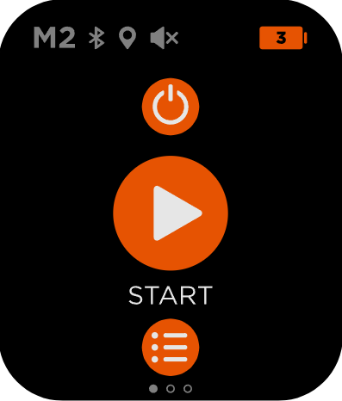

  - The device turns on the high-voltage output of the electrode and the display shows the measurement graphic.
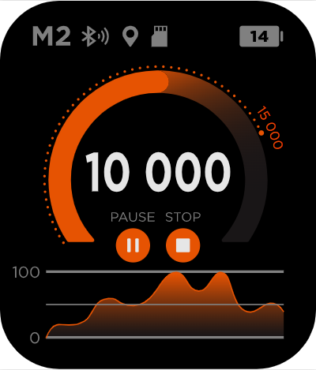

2. High voltage warning:
  - The presence of high voltage is indicated by the low tone emitted by the device from the speaker. This sound serves as a warning of the presence of high voltage.
3. Acoustic signaling at the start of the measurement:
  - Each time the measurement is started, the device beeps in a high-pitched tone, which is the same as the tone of the leakage signal found.
  - This high-pitched tone is used by the operator to verify that the acoustic signalling is on.
4. Setting the acoustic signalling:
  - The acoustic alarm can be set in the menu under Speaker.
Important notices:
- Make sure that you are aware of the presence of high voltage when starting the measurement and observe all safety regulations.
- Acoustic signaling is an important element of the safety and functionality of the device, so always verify its correct setting.

To turn off the measurement:
1. Switching off the high-voltage output:
  - The device turns off the high-voltage output when the user presses the Stop/ESC button on the device keyboard.
  - When the Stop/ESC button is pressed, the device stops emitting a low tone that signals the presence of a high voltage.
2. Return to the menu:
  - When the high-voltage output is switched off, the device menu appears on the display.
3. Alternative shutdown:
  - Pressing any key on the keyboard will also turn off the high-voltage output.
  - However, the correct procedure is to turn off the high-voltage output by pressing the ESC button, which will ensure the correct end of the measurement and return to the main menu.
Important notices:
- Always use the ESC button to turn off the measurement to ensure the correct termination of the high-voltage output and return to the device menu.

Notification of a leak found

On the display of the eRaptor 2.0 electrical device, you can see the number around which the orange runner moves. This runner displays the voltage value. The set value of the alarm is shown in dots around the runner. If the runner gets past the alarm value from the right side, the device will emit an audible alarm that may indicate a violation of the controlled non-conductive waterproofing layer.
This value decreases or jumps if the electrode approaches the defective point on the non-conductive waterproofing layer. Sparks may be emitted from the electrode near the integrity violation and a crackling sound from the electrodes can be heard and an alarm sounds from the loudspeaker.
On the device display there is a graph that continuously displays the measured values for the last 10 seconds. The chart is constantly refreshing, which means that values older than 10 seconds are no longer visible on the chart. This chart is used by the technician to check if there has been any anomaly during the last 10 seconds. If the device detects an anomaly, a “peak” will be displayed on the graph, which the technician can use to identify the problem moment and the subsequent next steps.

Completion of work with the device
- Turn the eRaptor 2.0 off .
- Let the device stand for 10 seconds without touching it so that all the electric charge is lost.
- Remove the grounding connector from the device
- Disconnect the device
- Remove the electrodes from the device.
- Clean the device
- Put in the transport case.

Device maintenance
- The eRaptor 2.0 electrical device should be kept clean due to possible creeping currents from the device. Clean only external parts, probes and cables. Use a soft cotton cloth lightly moistened with a mild detergent and water solution. In any case, do not allow any part of the electrical equipment to be submerged in liquid.
- Dry the probe and device thoroughly before any attempt to measure. Make sure that the connectors do not contain any dirt.
- Do not expose to solvents or their vapors as they may cause damage to the device body, probe and cables. This can lead to electric shock.
- Do not expose the connecting parts of the device (see Section 2) to direct sunlight that may disrupt the crystalline structure of polymers. Keep these parts of the device clean.
- If the device is damaged or flooded, contact a professional service and do not service the electrical device spontaneously.

Delivery contents
- 1x electrical device eRaptor 2.0 PRO
- 2x Stainless steel electrode 100
- 1x Charging adapter
- 1x USB-C Cable 1m
- 1x Protective suitcase with foam filling
- 1x eCable 150m

Storage of the device
Only use the ELISTECH suitcase supplied with the eRaptor 2.0 for safe storage and transport of the device. For long-term storage, store the eRaptor 2.0 with a battery charge of at least 40-60% and check the battery charge status regularly. The battery in the eRaptor 2.0 is self-discharging, regular charging prevents possible damage to the battery. Store the eRaptor 2.0 between 15 and 30 °C.

Elis Tech s. r. o. | Živnostenská 2 | 811 06 Bratislava | Slovak Republic
info@elis.tech | www.elis.tech

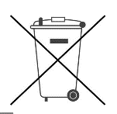


EU Declaration of Conformity

Elis Tech s. r. o.
Živnostenská 2, 811 06 Bratislava, Slovak Republic
as the manufacturer hereby declares that the product

Designation: Arc tester
Type: eRaptor 2.0 PRO
eRaptor 2.0 PRO GPS
eRaptor 2.0 PRO RTK
is in conformity with the relevant Union harmonisation legislation:
2014/53/EU (Radio Equipment Directive)
2014/35/EU (LVD Directive)
2014/30/EU (EMC Directive)
2006/42/EU (RoHS Directive)

The following harmonised standards and other technical specifications in relation to which conformity is declared have been applied:

EN 61010-1:2010/A1:2019/AC:2019-04
EN IEC 61010-2-034:2021/A11:2021
EN 61010:2008
EN 55011:2016/A1:2017/A11:2022
EN 300 328 V2.2.2

This declaration of conformity is issued under the sole responsibility of the manufacturer.



....................................................................
Mgr. Tomáš Gregor
(CEO)

In Bratislava on 5 August 2025

